Experiment 3

Aim:-Implement any one of the uninformed Searching algorithms ( DLS / IDDFS) by identifying and analyzing the given problem to reach the goal state.

Theory:-
Searching strategies are fundamental in problem-solving algorithms, particularly in scenarios where the solution is not immediately apparent. They play a crucial role in various domains such as artificial intelligence, operations research, and computer science. The significance of searching strategies lies in:
- Problem Solving: Searching strategies provide systematic methods to navigate through a problem space, allowing for the discovery of solutions or optimal paths.
- Resource Management: Different strategies optimize the utilization of computational resources such as time and memory, ensuring efficient exploration of the problem space.
- Completeness: Strategies are evaluated based on their ability to find a solution if one exists (completeness). This property is essential, especially in domains where finding a solution is critical.
- Optimality: Some strategies aim to find the optimal solution, minimizing the cost or resources required to reach the goal state. Optimality is a key consideration in decision-making processes.
- Scalability: Searching strategies should be scalable to handle large problem spaces efficiently. Scalability ensures that the algorithm remains effective even as the size of the problem space increases.

Difference between Uninformed and Informed Searching Strategies:
The distinction between uninformed and informed searching strategies lies in the use of domain-specific knowledge or heuristics:
- Uninformed Searching Strategies:

  - Uninformed strategies explore the problem space without any additional information other than the problem definition.
  - Examples include Breadth-First Search (BFS), Depth-First Search (DFS), Depth-Limited Search (DLS), and Iterative Deepening Depth-First Search (IDS).
  - These strategies are suitable for scenarios where little or no domain-specific knowledge is available, relying solely on systematic exploration of the search space.

- Informed Searching Strategies:
  - Informed strategies incorporate domain-specific knowledge or heuristics to guide the search towards the goal state more efficiently.
  - Examples include A* Search, Best-First Search, and Greedy Best-First Search.
  - By leveraging additional information about the problem domain, informed strategies can often find solutions faster or with fewer resources compared to uninformed strategies.

Comparison of Uninformed Searching Strategies:
When comparing uninformed searching strategies, several performance parameters are considered:
- Completeness: Whether the strategy guarantees finding a solution if one exists.
- Time Complexity: The computational time required to execute the algorithm, often expressed in terms of the number of vertices and edges in the search space.
- Space Complexity: The amount of memory required by the algorithm to store data structures during execution.
- Optimality: Whether the strategy guarantees finding the optimal solution, typically in terms of minimizing cost or resources.
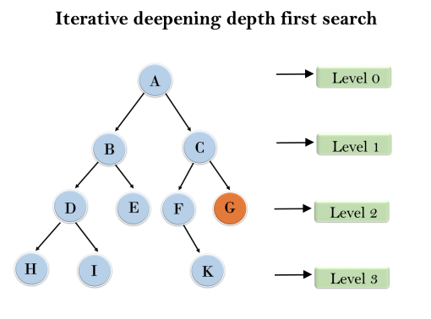
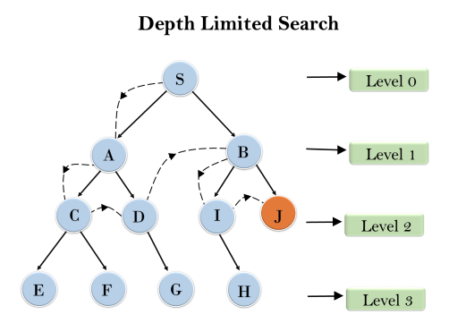

Performance Comparison of Uninformed Searching Strategies:
Strategy | Completeness | Time Complexity | Space Complexity | Optimality
BFS | Yes | O(V+E) | O(V) | Yes
DFS | No | O(V+E) | O(V) | No
UCS | Yes | O((V+E)logV) | O(V) | Yes
DLS | No | O(b^l) | O(bl) | No
IDS | Yes | O(b^d) | O(bd) | Yes
(Where V is the number of vertices, E is the number of edges, b is the branching factor, l is the depth limit, and d is the depth of the shallowest goal state.)
Problem: Finding a Path in a Maze
Problem Definition: Given a maze represented as a grid, with walls denoted by obstacles and open spaces representing possible paths, the task is to find a path from the start point to the goal point, if one exists.
Approach:
- State Representation: Each state represents a specific configuration of the maze, indicating the current position of the explorer.
- Actions: The actions available to the explorer are moving in any of the four cardinal directions (up, down, left, right) unless obstructed by a wall.
- Goal State: The goal state is reached when the explorer's position coincides with the goal position in the maze.
- Search Strategy: Depth-Limited Search will be employed to explore the maze, limiting the depth of exploration to avoid infinite loops or excessive memory consumption.
Code:-
#DLS
class TreeNode:
def __init__(self, data):
self.data = data
self.left = None
self.right = None

def find_dls(root, limit, target):
if limit <= 0 or root is None:
return False
if root.data == target:
print(root.data)
return True
print(root.data, "->", end=" ")
return find_dls(root.left, limit - 1, target) or find_dls(root.right, limit - 1, target)
def create_tree():
root = TreeNode(1)
root.left = TreeNode(2)
root.right = TreeNode(3)
root.left.left = TreeNode(4)
root.left.right = TreeNode(5)
root.right.left = TreeNode(6)
root.right.right = TreeNode(7)
root.left.left.left = TreeNode(8)
root.left.left.right = TreeNode(9)
root.left.right.left = TreeNode(10)
root.left.right.right = TreeNode(11)
return root
if __name__ == "__main__":
root = create_tree()
print('DLS')
limit = int(input("Enter the limit: "))
target = int(input("Enter the target: "))
result = find_dls(root, limit, target)
print(result)

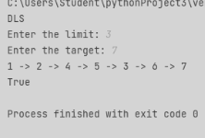

IDDFS:-
class TreeNode:
def __init__(self, data):
self.data = data
self.children = []
def iddfs(root, target):
depth = 0
while True:
print("Iteration {}: ".format(depth + 1), end="")
found = dls(root, target, depth)
print()
if found:
print("Target found.")
return True
depth += 1
def dls(node, target, depth):
if depth == 0 and node.data == target:
print(node.data, end=" ")
return True
elif depth > 0:
print(node.data, end=" ")
for child in node.children:
if dls(child, target, depth - 1):
return True
return False
root = TreeNode(1)
root.children = [TreeNode(2), TreeNode(3)]
root.children[0].children = [TreeNode(4), TreeNode(5)]
root.children[1].children = [TreeNode(6), TreeNode(7)]
root.children[0].children[0].children = [TreeNode(8), TreeNode(9)] # Corrected assignment
root.children[0].children[1].children = [TreeNode(10), TreeNode(11)] # Corrected assignment
root.children[1].children[1].children = [TreeNode(12), TreeNode(13)] # Corrected assignment
target = int(input("Enter the target node: "))
iddfs(root, target)

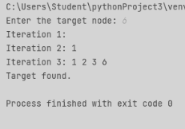

Conclusion:-
In Conclusion,uninformed searching strategies provide a fundamental framework for exploring problem spaces systematically. While they may lack the efficiency of informed strategies, they offer simplicity and applicability to a wide range of problems. Each uninformed strategy has its advantages and limitations, making them suitable for different problem scenarios based on factors like search space size, branching factor, and solution optimality requirements.

